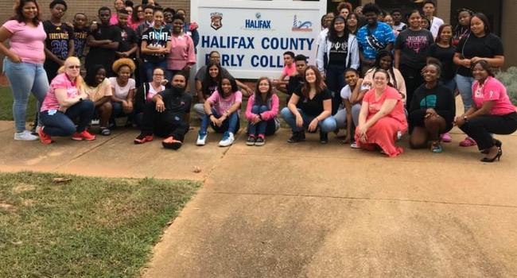

*Charting a New Course*

Halifax County Early College

**Halifax County Early College**

**100 College Dr**

**Weldon, NC 27890**

**Phone: 252-536-5461**

**Fax: 252-536-5493**

**Website: https://www.halifax.k12.nc.us/Domain/662**

**Email: williamsj@ec.halifax.k12.nc.us**



Þ Small school setting

Þ Continuous support for academic

success

Þ Free, transferable college credit while attending high school

Þ Programs and courses to boost academic achievement

Þ Graduate with a high school diploma and a two-year college degree

Þ Classroom instruction by

outstanding teachers and college professors

Benefits



**About us:**

* **Official Name:** Halifax County Early College
* **Location:** Halifax Community College Campus, 100 College Dr. Weldon NC
* **Opening date:** August 2019
* **Grade Span:** 9-13
* **Program:** Offers combination of tradi- tional high school courses and college courses
* **Degrees:** High School Diploma, AAS, AA, Industry Certifications; Transfer Plan of Study 2x2
* **Number of courses per day:** Four 90 min blocks and up to six classes per semester
* **Elective Courses:** Focus is on courses for the Associates Degree
* **Transportation:** Provided by Halifax County Schools
* **School Calendar:** Aligned with the col- lege calendar

**Selection Process**

Selection for the Halifax County Early College is con- ducted through an application process. Students who are current eighth and ninth graders may apply to attend for the upcoming school year. Students should contact their school counselor for an application and more information.



* ***A school for the real world with a focused environment for accelerated learning***
* ***A school committed to academic excellence and success for All students***
* ***Goals:***

***The goals for Halifax Early College High School are***

* ***Provide exceptional educational opportunities for students who seek a challenge above and beyond the traditional high school curriculum***
* ***Foster a “college-going” culture and encourage students to complete the Associates Degree program***
* ***Offer a college experience for first-generation***

***college students who may not have the financial means to attend***

***Imagine***

Halifax Early College High School



Overview Impressive Opportunities

Halifax County Early College (HCEC} is an exciting Innovative high school located on the Halifax Community College campus in Weldon, NC. The Halifax Early College High School is operated by the Halifax County Schools and Halifax Community College through a joint partnership.

This non-traditional high school offers Halifax County students a unique opportunity to receive a high school diploma while earning and Associates degree from the Halifax Community College.

Halifax County Early College boast of real-world, rigorous academics. The school allows high school students to take college courses at no additional cost. After graduation, students may transfer to a four-year college or university.

The Halifax County Early College is an exceptional opportunity for students who would like a small setting as well as the desire to work hard and optimize potential to be our future leaders.

* Offers accredited studies with a more challenging curriculum
* Expands and enriches student knowledge
* Prepares students for four-year college classrooms
* Allows students to graduate from high school with an Associate Degree or transferable college credit and industry credentials
* Provides students a chance to learn about college life while still in high school
* Features collaboration with post-secondary institutions that develops a seamless education experience
* Supports students academically, socially and physically

***Be a part of Halifax County Schools History***